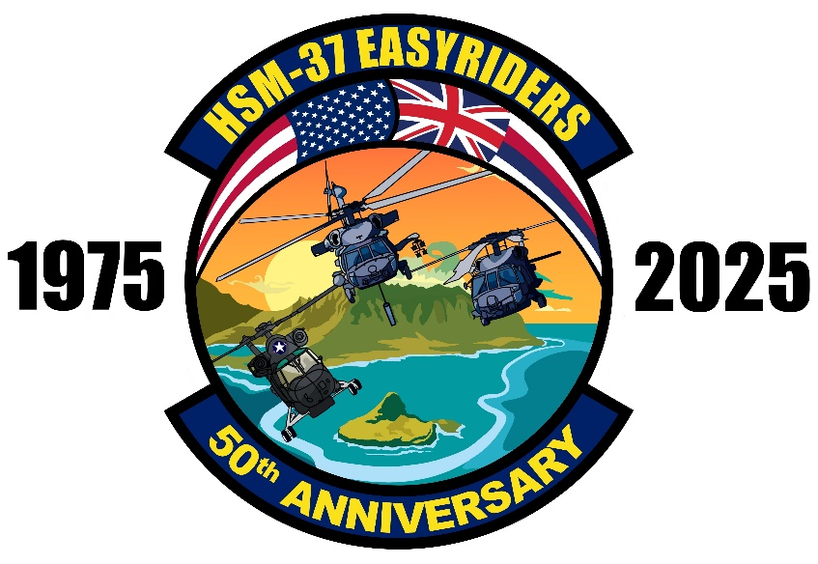

CDR Michael S. Moorse
Commanding Officer, Helicopter Maritime Strike Squadron Three Seven
Cordially invites all HSM-37 Easyriders
to a commemoration of the
50th Anniversary of the Easyriders
Hangar 101, MCAS Kaneohe Bay, HI
Schedule of Events
02 JULY 2025
0900-1000 | 50th Anniversary Ceremony (Hangar 101)
1100-1500 | Squadron and Simulator Tours (Hangar 101 / Building 6701)
1200 | Golf Tournament (Klipper Golf Course)
03 JULY 2025
0800-1200 | Simulator Tours (Building 6701)
1200-1900 | Easyrider Luau (Bellows Beach Deck)

Scan to RSVP!
Check out our Facebook page more information!


Since July 3, 1975 the Easyriders of HSM-37 have been proud to be “The best damn squadron in PACFLT” and its time to celebrate the endless list of accomplishments with all of you for our 50th anniversary. July 2-3, 2025 we are opening our hangar to Easyrider alumni, friends, family, and Naval Aviation enthusiasts to showcase the Aloha spirit we pride ourselves in.
We will have a ceremony on July 2nd to kick off the festivities along with Static tours of the aircraft, simulator time to test your flying abilities, and a golf tournament. Lastly we will conclude the event with a beachside luau on July 3rd to tell sea stories of the original SH-2, the SH-60B, and MH-60R
We hope to see you all in Oahu at Marine Corps Station Kaneohe Bay for what is sure to be a fantastic celebration of the storied history of the world famous HSM-37 Easyriders!

The schedule is as follows
02 JULY 2025
0900-1000 | 50th Anniversary Ceremony (Hangar 101 MCBH)
1100-1500 | Squadron and Simulator Tours (Hangar 101 / Building 6701 MCBH)
1200 | Golf Tournament (Klipper Golf Course, MCBH)
03 JULY 2025
0800-1200 | Simulator Tours (Building 6701, MCBH)
1200-1900 | Easyrider Luau (Bellows Air Force Station Beach Pavillion A/B)

The cost for all events with the exception of the golf tournament is free. Base access for those without CAC cards will be coordinated with prior reservations required.
Lodging is available on a first come first serve basis at the Inn of the Corps and other base lodging options as well as numerous options in the beautiful town of Waikiki
Uniform of the day is Flight Suits/Type III or Aloha Casual for civilians!
Please use the QR code in the attached flyer to RSVP!
For any questions please reach out to LCDR Cotter “BAE” Walker at cotter.a.walker.mil@us.navy.mil or 407-427-6825

